

**Kount Integration**

Version 1.0



Table of Contents

1. Summary 1-3

2. Component Overview 2-4

2.1 Functional Overview 2-4

2.2 Limitations, Constraints 2-4

2.3 Compatibility 2-4

2.4 Privacy, Payment 2-4

3. Implementation Guide 3-5

3.1 Setup 3-5

3.2 Configuration 3-5

3.3 Custom Code 3-13

3.4 External Interfaces 3-15

3.5 Testing 3-16

4. Operations, Maintenance 4-22

4.1 Data Storage 4-22

4.2 Availability 4-22

4.3 Support 4-22

5. User Guide 5-23

5.1 Roles, Responsibilities 5-23

5.2 Business Manager 5-23

5.3 Storefront Functionality 5-23

6. Known Issues 6-24

7. Release History 7-24

Appendix A : Manual installation instructions for custom System Object definitions & Kount Site Preferences.

Appendix B : Test Cases

# Summary

Kount is a leading innovator of solutions for fraud and risk management. Kount's “decision engine” platform is ideal for managing fraud in online/telephone channels that process payments and onboard new customers. Kount is committed to offering an end-to-end, single-source solution focused on speed, simplicity and ease of use...with a no-compromise approach to providing real-time accuracy in results.

The Kount Demandware cartridge will provide rapid integration for Demandware implementations. The Kount cartridge is a self-contained cartridge that can easily integrate into any project. This cartridge can be configured in the Business Manager and contains all elements necessary to perform a successful best practices implementation of Kount.

The Kount Demandware cartridge can be obtained from:

Demandware Secured LINK Marketplace Website

Request from your Kount Technical Account Manager

Requirements for Kount Demandware cartridge:

All steps from UX Studio Installation & Sandbox Setup Guide (from Demandware) have been completed

Open SSL is installed locally with no additional libraries installed

A Demandware Development Resource: The Integration and installation process includes deployment of a generic cartridge and modification of storefront code & pipelines.

# Component Overview

## Functional Overview

Kount cartridge provides integration for such functionality:

1. RIS(Risk Inquiry System) and Data collector implementation in checkout process;
2. ENS(Event Notification System) callback.

## Limitations, Constraints

*Limited Payment Methods; currently only Credit Card.*

*No AVS or CVV information has been passed.*

## Compatibility

Cartridge designed for Demandware API version 13.1.

Compatibility Mode: 10.6

## Privacy, Payment

Kount supports different payment types and depends on chosen by the customer payment type (payment tokens are required). If chosen payment method not supported by Kount, then a value of NONE should be passed.

The integration uses customer profile data, and transfers it to Kount. Hashed credit card data is sent to Kount system. The following credit card data is sent:

* Masked credit card number (Salted Irreversible Hash; PCI Level 1 Compliant)
* Card holder name
* Credit card type

# Implementation Guide

## Setup

The **int_kount** cartridge is required for the integration. Please obtain the cartridge from your Kount Technical Account Manager. The cartridge will also be available to all Demandware merchants via their secured LINK Marketplace website.

|  |  |
| --- | --- |
| Cartridge name | int_kount |
| Pipelines | Kount.xml  KountENS.xml |
| Scripts | kount/IPFilter.ds  kount/KountUtils.ds  kount/LibKount.ds  kount/PostRiskInqueryService.ds  kount/SelectEventNodeName.ds  kount/UpdateCustomAttribute.ds  kount/UpdateOrder.ds |
| CSS | kount.css |
| Templates | kount/confirmationENS.isml  kount/iframe.isml  kount/logo.isml  mail/risk_change.isml  resources/kount.properties |
| Metadata | kount_metadata.xml |

## Configuration

The integration requires 5 configuration steps:

1. Use **Site Import** to Create Custom System Object Definitions &Setting Kount Site Preferences for each site
2. Certificate Conversion and Certificate & Key file Import to Business Manager
3. Configuring the Event Notification Service
4. Assign the Cartridge to a Site
5. Modify Storefront Code and Pipelines

*Note: Manual integration instructions for step 1 can be found in Appendix A.*

# Using Site Import

Use the kount_metadata.xml file to create the custom System Object definitions and configure the Kount Site Preferences.

* + 1. Login into Demandware Business Manager.
    2. 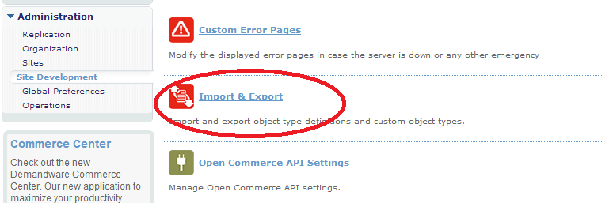Select the Administration section -> Site Development -> Import & Export
    3. Select the **Upload** button to upload the kount_metadata.xml file.

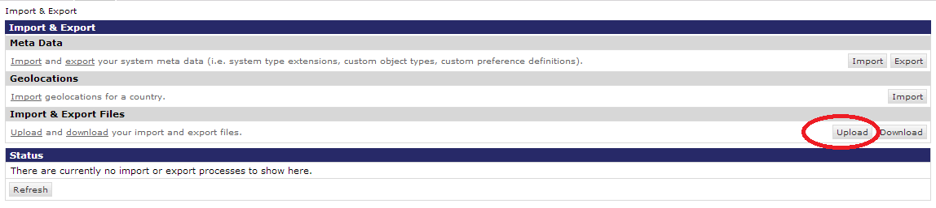

* + 1. Select the Choose File button and navigate to the kount_metadata.xml file. Select the Upload button.  
       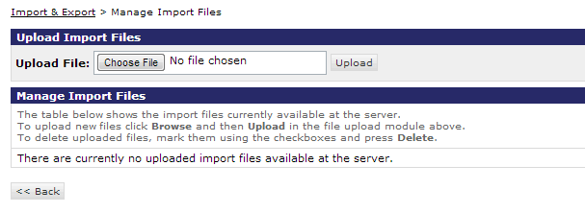

Notice that now the kount_metadata.xml file is listed within the Manage Import Files page.

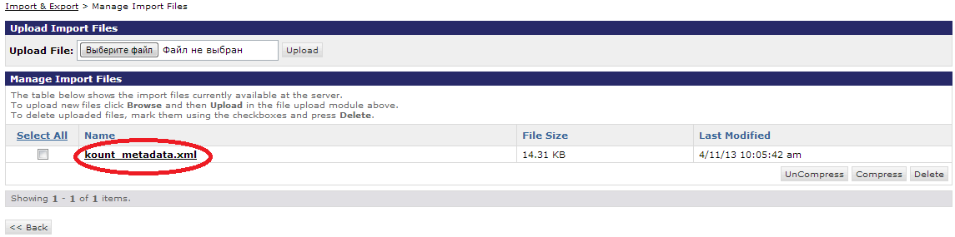

* + 1. Navigate back to the Import & Export page.
    2. 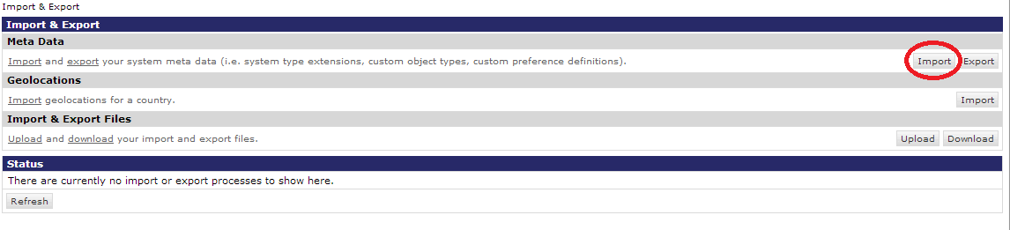Select the Import button.
    3. Select the radio button next to the kount_metadata.xml file and choose the Next button. An XML Validation will run.

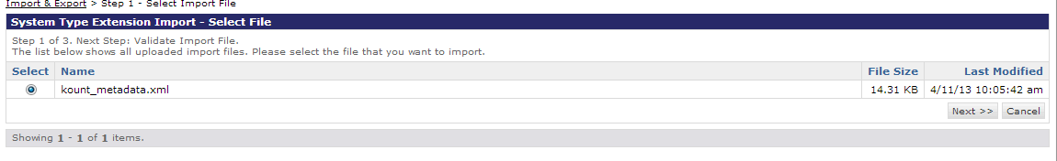

* + 1. Select the **Import** button.

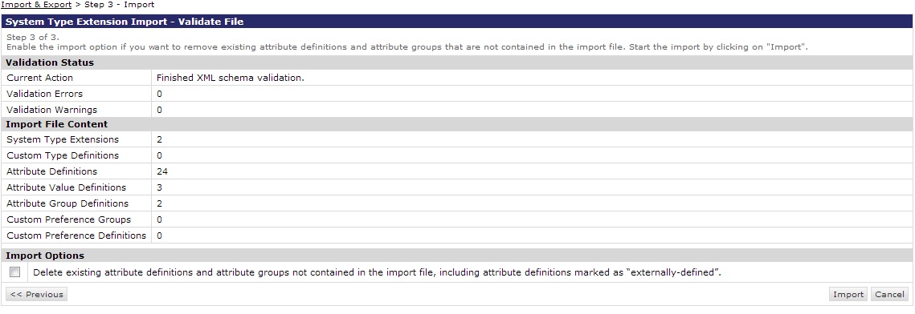

After the import has finished a “Success” status will display.

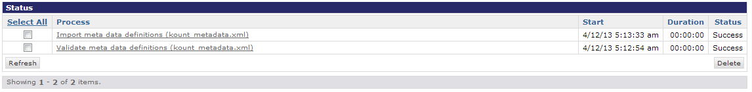

*NOTE: If a Status of Success does not display, then check the Demandware Sandbox Setup (Site Genesis) and complete steps 6-8 again. Note: The Demandware Sandbox will need to be rebooted (from Demandware) before the some site changes will take effect. Sandboxes are rebooted automatically every night.*

# Setting the Kount Site Preferences

The Kount Site Preferences will need to be filled into the fields within this page. The script file will display the default values to the right of the screen, but does not populate the fields automatically. Verify the Site Preferences by navigating to Site -> Site Preferences -> Custom Preferences. Select Kount. The Custom Site Preferences page will display. All Sandbox Boarding information needed for this page will be provided by your Kount Technical Account Manager at the conclusion of the initial Merchant KickOff Boarding Meeting.

*Important: The URL’s provided for Sandbox Boarding will not be used in the Production environment. Production Boarding information will be provided to the Merchant following their certification, authorizing the Merchant to begin sending production traffic. Contact your Technical Account Manager if you have any questions or concerns.*

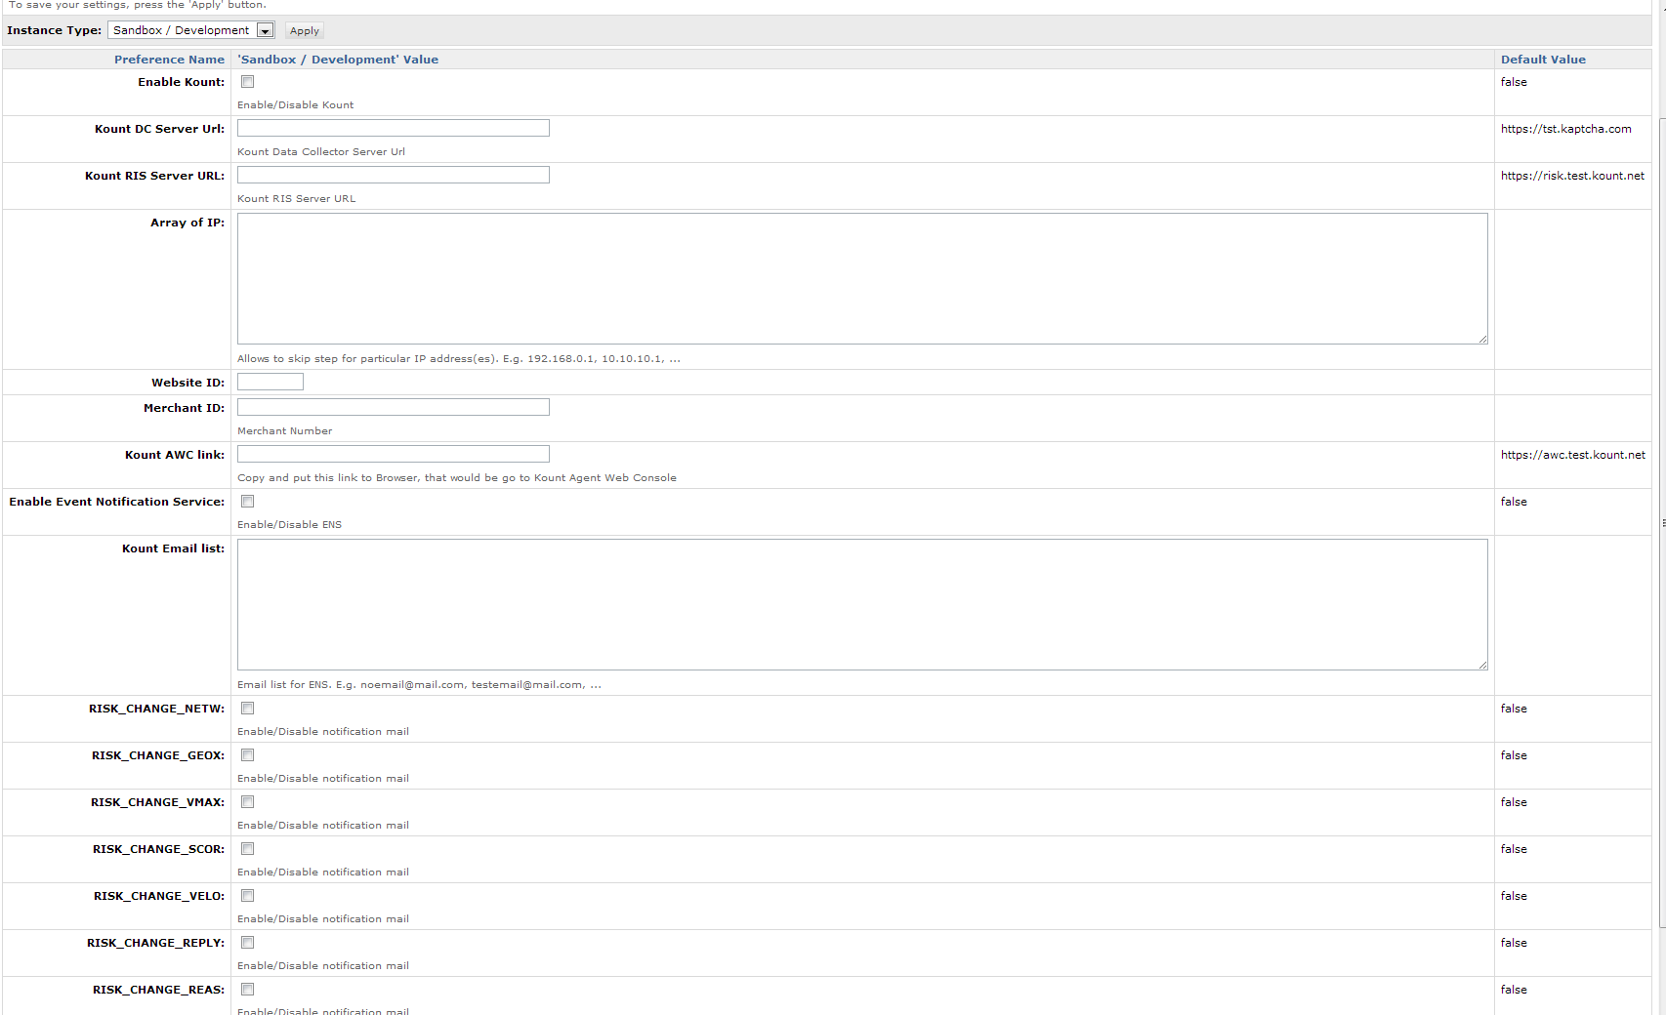

# Certificate Conversion and Certificate & Key File Import into Business Manager

A RIS Certificate must be created, converted and imported into the Demandware Business Manager. Further detail regarding the RIS Certificate can be obtained within the Kount Technical Specification Guide and the Certificate Export and Conversion Guide.

*Note: The following instructions assume that:*

* *A X.509 Self Signed certificate has been created from the Agent Web Console.*
* *OpenSSL has been installed with no additional libraries*
* *The original .p12 or .pfx file reside within the OpenSSL directory (no friendly pathing).*

1. Convert the original .p12 to a .pem format certificate using the following command line instruction from OpenSSL.  
   

Enter the password used to create the file during the initial export of the certificate from the browser. A “MAC verified OK” message will display if the password was entered correctly.



1. To import the converted certificate and original .p12 or .pfx private key file into the Business Manager navigate to Administration -> Operations -> Private Keys and Certificates.
2. Select the **Import** button (as shown below).

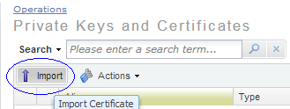

1. Browse to the location of the converted pem certificate file. Enter <https://risk.test.kount.net> within the Alias field. Select the Import button.  
     
   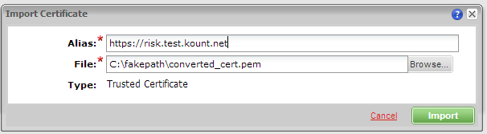
2. Select the Import button again.  
     
   
3. Browse to the original .p12 or .pfx file that was exported from the browser.  
   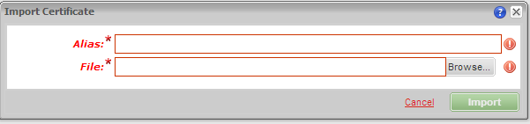  
     
   As soon as you open the .p12 or .pfx file the dialog box will change. Enter ris_private_key within the Alias field. Enter the password that was used to create the certificate. Enter <https://risk.test.kount.net> within the Host Names field and choose the ADD button similar to the image below. Select the Import button.  
     
   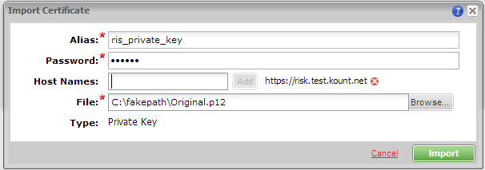  
     
   The Private Keys and Certificates will display below with grayed out dates and import confirmation until the Demandware Sandbox is rebooted. The Demandware Sandbox automatically reboots every night.

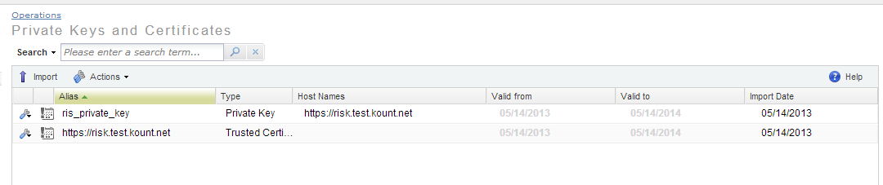  
  
Below is how the Private Key and Certificate will display after the Demandware Sandbox has been rebooted.

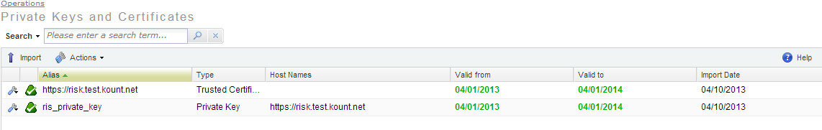

*Important: New Certificate and Key Files will need to be created for use within the Production environment. The URL’s provided for Sandbox Boarding will not be used in the Production environment. Production Boarding information will be provided to the Merchant following their certification,   
authorizing the Merchant to begin sending production traffic.   
Contact your Technical Account Manager if you have any questions or concerns.*

Configuring the Event Notification Service

To configure the Event Notification Service (ENS) a Merchant URL will need to be set within Demandware and within the Kount Agent Web Console. All Event Notifications will be sent to this URL as an XML post.

1. Identify the Merchant URL. Use the example below to help discover your unique URL.

Example of Event Notification System URL:

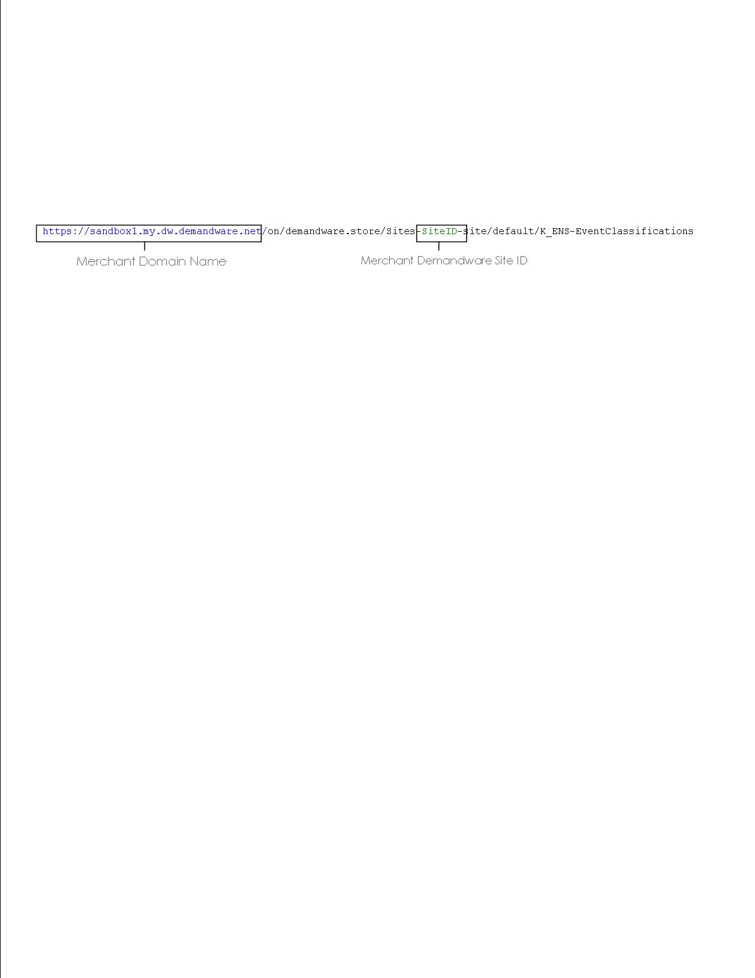  
The rest of the URL is primarily static values. The “default” value may be different if the merchant is using another language aside from English.

1. Set the ENS URL within Kount, navigate to the Fraud Control tab -> Websites. Select the GEAR, (circled in the image below).

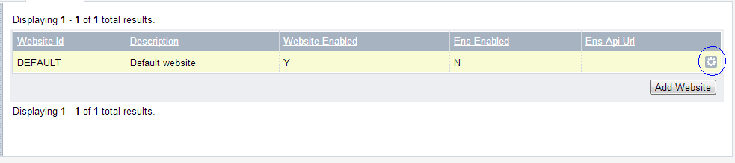

1. The Edit Row dialog will display. Choose the ENS Enabled Radio button. Enter the ENS URL (that is unique to your merchant account) within the Merchant ENS URL field. Select the Update Website button.

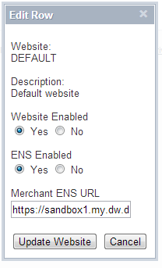 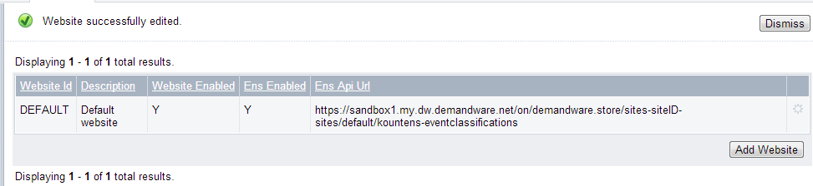

Notice the confirmation in the upper left stating the Website was successfully edited.

# Assign the Cartridge to a Site

The Cartridge will need to be assigned to the Merchant’s website & Business Manager.

1. Navigate to Administration -> Sites -> Manage Sites. Select the appropriate site(s).
2. Add the cartridge into the cartridge list for each site where Kount is needed by including the following prefix within the cartridge field:

int_kount:

1. 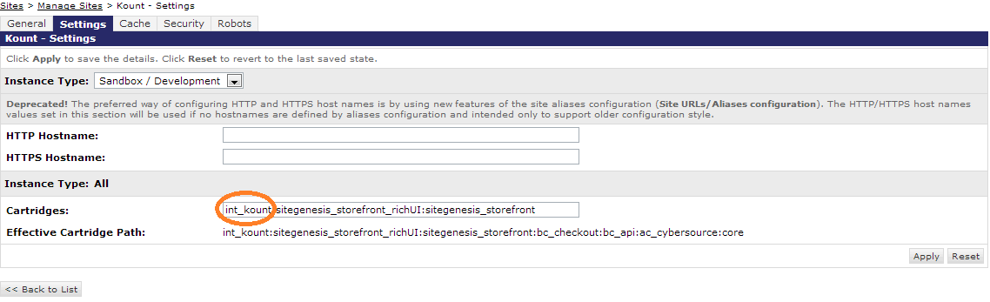Select the Apply button.
2. Navigate to Administration -> Sites -> Manage Sites. Select **Manage the Business Manager** site.
3. Add the cartridge into the cartridge list for the Business Manager by including the following prefix within the cartridge field:

int_kount:

1. Select the Apply button.

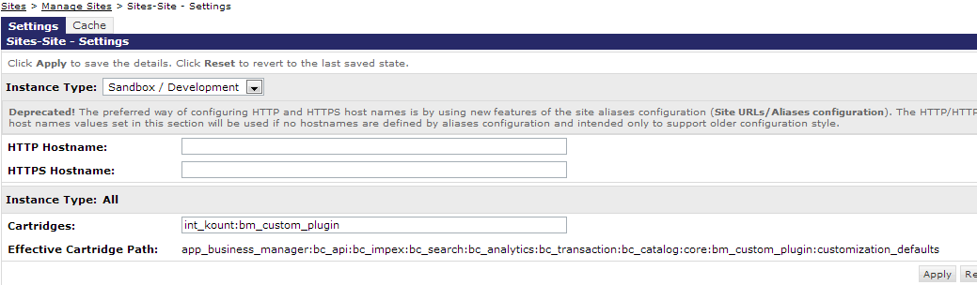

Custom Coding Requirements & Instructions

There are portions of the Kount cartridge implementation that require additions to the internal coding & pipelines of the Demandware storefront code. Please consult with your Demandware development resources to complete this portion of the Kount integration.

Navigate in Eclipse to your storefront cartridge. Other editors maybe used, the following steps are documented for use with Eclipse. Please reference the Demandware Test Drive documentation for further information.  
  
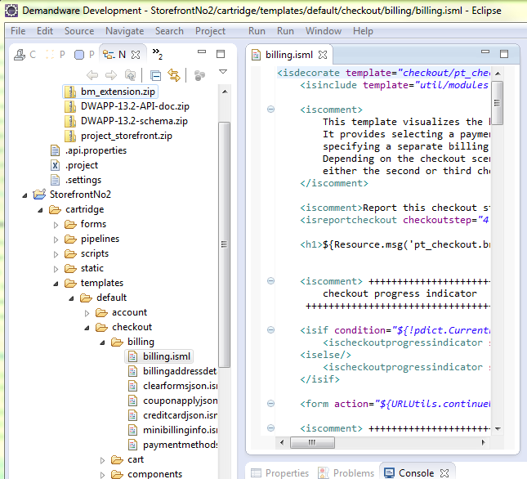

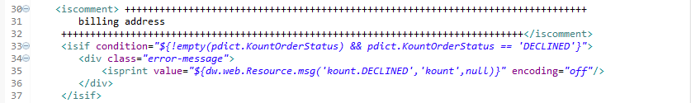Open the Template folder navigate to checkout/billing/billing.isml (as shown above) and find the billing address line that displayed in the screenshot below.

Insert these additional lines of code (as shown in the example) and **save the file.**

<isif condition=*"${!empty(pdict.KountOrderStatus) && pdict.KountOrderStatus == 'DECLINED'}"*>

<div class=*"error-message"*>

<isprint value=*"${dw.web.Resource.msg('kount.DECLINED','kount',null)}"* encoding=*"off"*/> </div>

</isif>

Remaining within the Template folder, navigate to 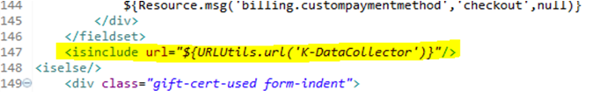checkout/billing/paymentmethods.isml and find line displayed in the screenshot below. (Tip: Turn on Line No.’s to locate.)  
  
Insert the additional line of code (as shown in the example) and **save the file**.

<isinclude url*="${URLUtils.url('K-DataCollector')}"/*>

Open the Pipeline folder, navigate to COPlaceOrder.xml (Tip: Use Ctrl+Shift+R to search if you are using Eclipse) and insert Call Node, insert some changes:

* 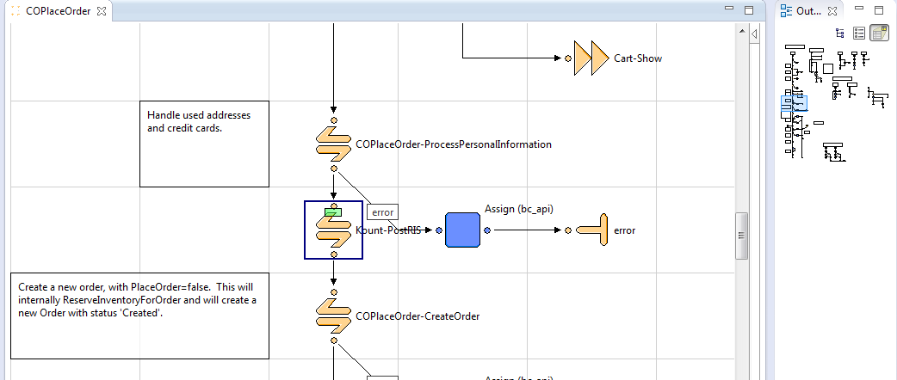To create the Risk Inquiry Service(RIS) post we must insert K-PostRIS Call Node
* To update Demandware with the results of the Kount Risk Evaluation, we must insert a K-UpdateOrder Call Node

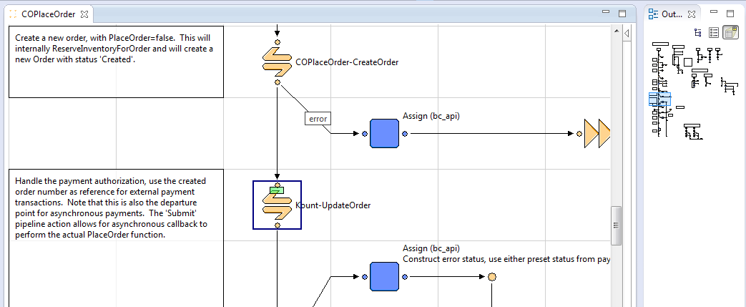

* A value must also be defined for order number. Find Start Node COPlaceOrder-CreateOrder and insert value for pipelet CreateOrder2, the value for the *OrderNo* Property equals **OrderNo**

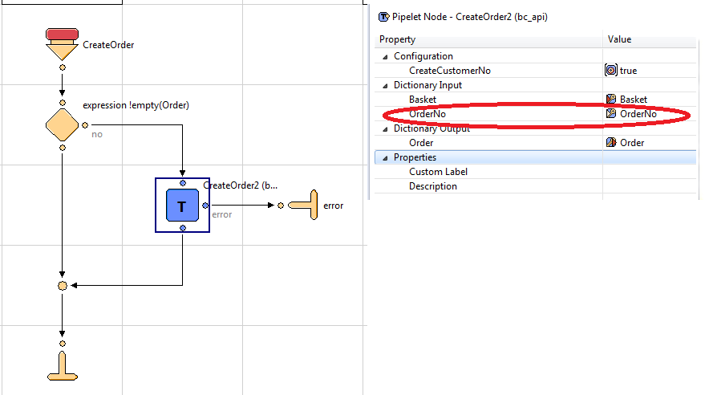

## External Interfaces

The cartridge uses Event Notification System to synchronization with the Kount.

**Callback Pipelines:**

For ENS we have set events and the Kount service notifies Demandware using callback. There are several callback pipelines that process the following changes:

* KountENS- EventClassifications – determining what kind of event comes
* KountENS- SpecialAlertTransaction, WorkflowStatusEdit, WorkflowReevaluate, RiskChangeScor, RiskChangeReply, RiskChangeVelo, RiskChangeVmax, RiskChangeGeox, RiskChangeNetw, RiskChangeReas - appropriate event handlers

# Operations, Maintenance

## Data Storage

All needed data is stored on Order level in custom fields: Kount Order Status, Kount Order Transaction ID, Kount Order REAS, Kount Order GEOX, Kount Order NETW, Kount Order SCOR, Kount Order VELO, Kount Order VMAX.

## Availability

Intentionally left blank.

## Support

Kount Operations

24 x 7 x 365

1-866-940-6722

[support@kount.com](mailto:support@kount.com)

# User Guide

## Roles, Responsibilities

*Intentionally left blank.*

## Business Manager

Configuration options described above, in 3.1.

## Storefront Functionality

*Intentionally left blank.*

# Known Issues

*Intentionally left blank.*

# Release History

|  |  |  |
| --- | --- | --- |
| **Version** | **Date** | **Changes** |
| 1.0.0 | April 9, 2013 | Initial release |

Appendix A: Manual Integration Steps

**Create System Object Definitions (manual integration method)**

1. Create the following system object definitions:

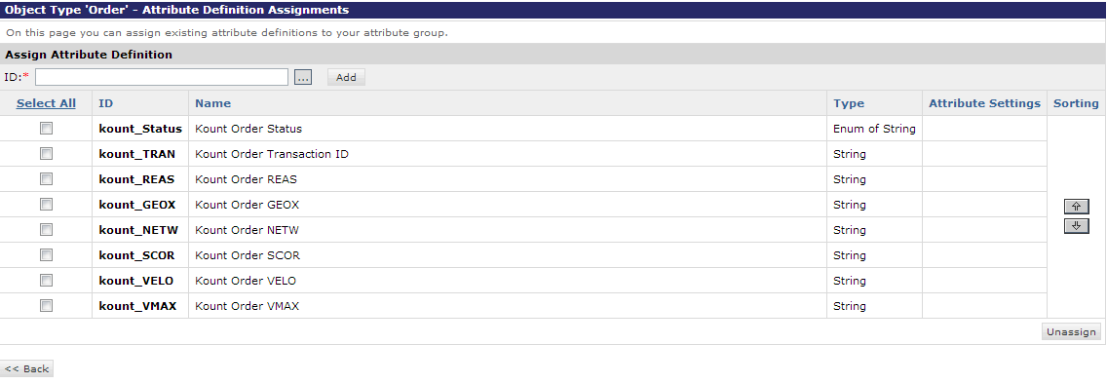

* Order
  + Kount Order Status
    - id: kount_Status
    - display name: Kount Order Status
    - type: Enum of Strings
    - mandatory: false
    - values:
      * value: APPROVED, display value: Approved
      * value: HOLD, display value: Hold
      * value: DECLINED, display value: Declined
      * value: CHANGE, display value: Change
      * value: TIME OUT, display value: Time Out
      * value: TIME OUT PAYMENT, display value: Time Out Payment Authorization
  + Kount Order NETW
    - id: kount_NETW
    - display name: Kount Order NETW
    - type: String
    - mandatory: false
  + Kount Order GEOX
    - id: kount_GEOX
    - display name: Kount Order GEOX
    - type: String
    - mandatory: false
  + Kount Order REAS
    - id: kount_REAS
    - display name: Kount Order REAS
    - type: String
    - mandatory: false
  + Kount Order SCOR
    - id: kount_SCOR
    - display name: Kount Order SCOR
    - type: String
    - mandatory: false
  + Kount Order TRAN
    - id: kount_TRAN
    - display name: Kount Order TRAN
    - type: String
    - mandatory: false
  + Kount Order VELO
    - id: kount_VELO
    - display name: Kount Order VELO
    - type: String
    - mandatory: false
  + Kount Order VMAX
    - id: kount_VMAX
    - display name: Kount Order VMAX
    - type: String
    - mandatory: false

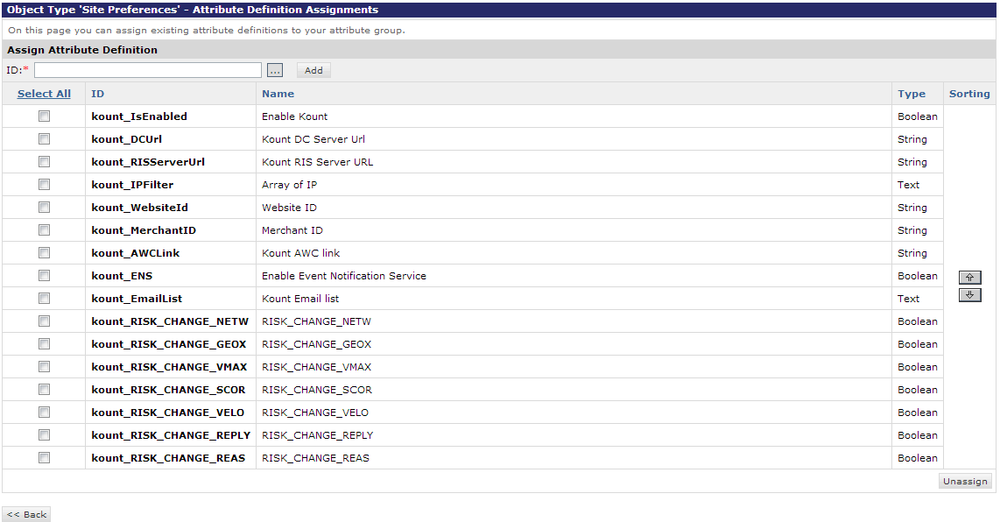

* Site Preferences
  + Enable Kount
    - id: kount_IsEnabled
    - display name: Enable Kount
    - type: Boolean
    - mandatory: false
  + Kount DC Server Url
    - id: kount_DCUrl
    - display name: Kount DC Server Url
    - description: Kount Data Collector Server Url.
    - type: String
    - mandatory: false
    - default value: https://tst.kaptcha.com
  + Kount RIS Server URL
    - id: kount_RISServerUrl
    - display name: Kount RIS Server URL
    - description: Kount RIS Server URL
    - type: String
    - mandatory: false
    - default value: https://risk.test.kount.net
  + Array of IP
    - id: kount_IPFilter
    - display name: Array of IP
    - description: Allows to skip step for particular IP address(es). E.g. 192.168.0.1, 10.10.10.1, ...
    - type: Text
    - mandatory: false
  + Website ID
    - id: kount_WebsiteId
    - display name: Website ID
    - type: String
    - mandatory: false
    - minimum value: 1
    - field length: 8
  + Merchant ID
    - id: kount_MerchantID
    - display name: Merchant ID
    - description: Merchant Number
    - type: String
    - mandatory: false
  + Kount AWC link
    - id: kount_AWCLink
    - display name: Kount AWC link
    - description: Copy and put this link to Browser, that would be go to Kount Agent Web Console
    - type: String
    - mandatory: false
    - default value: <https://awc.test.kount.net>
  + Enable Event Notification Service
    - id: kount_ENS
    - display name: Enable Event Notification Service
    - description: Enable/Disable ENS
    - type: Boolean
    - mandatory: false
  + Kount Email list
    - id: kount_EmailList
    - display name: Kount Email list
    - description: Email list for ENS. E.g. noemail@mail.com, testemail@mail.com, ...
    - type: Text
    - mandatory: false
  + RISK_CHANGE_GEOX
    - id: kount_RISK_CHANGE_GEOX
    - display name: Kount Email list
    - description: Enable/Disable notification mail
    - type: Boolean
    - mandatory: false
  + RISK_CHANGE_NETW
    - id: kount_RISK_CHANGE_NETW
    - display name: Kount Email list
    - description: Enable/Disable notification mail
    - type: Boolean
    - mandatory: false
  + RISK_CHANGE_REAS
    - id: kount_RISK_CHANGE_REAS
    - display name: Kount Email list
    - description: Enable/Disable notification mail
    - type: Boolean
    - mandatory: false
  + RISK_CHANGE_REPLY
    - id: kount_RISK_CHANGE_REPLY
    - display name: Kount Email list
    - description: Enable/Disable notification mail
    - type: Boolean
    - mandatory: false
  + RISK_CHANGE_SCOR
    - id: kount_RISK_CHANGE_SCOR
    - display name: Kount Email list
    - description: Enable/Disable notification mail
    - type: Boolean
    - mandatory: false
  + RISK_CHANGE_VELO
    - id: kount_RISK_CHANGE_VELO
    - display name: Kount Email list
    - description: Enable/Disable notification mail
    - type: Boolean
    - mandatory: false
  + RISK_CHANGE_VMAX
    - id: kount_RISK_CHANGE_VMAX
    - display name: Kount Email list
    - description: Enable/Disable notification mail
    - type: Boolean
    - mandatory: false

2. Create an attribute group for Kount site preferences and add fields.

* id: Kount
* display name: Kount
* attributes:
  + kount_IsEnabled
  + kount_DCUrl
  + kount_RISServerUrl
  + kount_IPFilter
  + kount_WebsiteId
  + kount_MerchantID
  + kount_AWCLink
  + kount_ENS
  + kount_EmailList
  + kount_RISK_CHANGE_NETW
  + kount_RISK_CHANGE_GEOX
  + kount_RISK_CHANGE_VMAX
  + kount_RISK_CHANGE_SCOR
  + kount_RISK_CHANGE_VELO
  + kount_RISK_CHANGE_REPLY
  + kount_RISK_CHANGE_REAS

Appendix B : Test Cases

# Verifying the Functionality of the Cartridge: Test Cases

**General Prerequisites:**

Requirements for Test Cases:

1. Link to send box server and Business Manager credentials.

2. Kount account ([https://awc.test.kount.net](https://awc.test.kount.net/))

3. In your browser installed Firebug or another tool, which help you to see page sources.

**TestCase 1:   
BusinessManger. Kount preferences. Check required fields.**

Steps:

1. Login to BM and open Kount > Site Preferences > Custom Preferences > Kount.

2. Verify that next components are available:

- Enable Kount checkbox

- Kount DC Server Url field

- Kount RIS Server URL field

- Array of IP textarea

- Website ID field

- Merchant ID field

- Kount AWC link field

- Enable Event Notification Service checkbox

- Kount Email list textarea

- RISK_CHANGE_NETW

- RISK_CHANGE_GEOX

- RISK_CHANGE_VMAX

- RISK_CHANGE_SCOR

- RISK_CHANGE_VELO

- RISK_CHANGE_REPLY

- RISK_CHANGE_REAS

- Apply and Reset buttons

**TestCase 2.**

**BusinessManager. Order options. Check kount field.**

Steps:

1. Login to BM and open Kount > Ordering > Orders > Find Order.

2. Open Attributes tab.

3. Verify that there is Kount Order Status select field, with next options:

- Approved

- Hold

- Declined

- Change

- Time out

- Time out payment

4. Verify that there are other fields:

- Kount Order Transaction ID

- Kount Order REAS

- Kount Order GEOX

- Kount Order NETW

- Kount Order SCOR

- Kount Order VELO

- Kount Order VMAX

**TestCase 3.**

**BusinessManager. Private Keys and Certificates. Check kount keys and certificates.**

Steps:

1. Login to BM and open Administration > Operations > Private Keys and Certificated.

2. Verify that Kount Private Key and 2 Trusted Certificates are available.

**TestCase 4.**

**BusinessManager Configuration. Test Mode. Check iframe.**

Prerequisites:

Set Kount cartridge to Test Mode:

- Login to BM and open Kount > Site Preferences > Custom Preferences > Kount.

- Set Kount DC Server Url: [https://tst.kaptcha.com](https://tst.kaptcha.com/)

- Apply changes.

Steps:

1. Open Store Front.

2. Choose some product, add it to Cart and start Checkout as Guest.

3. On Shipping page enter a shipping address, select shipping method and click Continue button.

4. Scroll down Billing page and verify that more left than Continue button, there is a pixel (little blue rectangle).

5. Click on pixel with right button and choose in context menu - Inspect Element.

6. Verify that pixel - is a div with class = “iframe_test” and contains inside iframe component.

7. Using prompt in Prerequisites set: Set Kount DC Server Url: [https://kaptcha.com](https://tst.kaptcha.com/)

8. Open again Billing page and verify that pixel have no visualization(absent little blue rectangle).

9. Open page sources(e.g. using Firebug), search for iframe.

10. Verify that iframe component is still there and div around it is without class.

**TestCase 5.**

**Business Manager Configuration. Set self ip to Array of IP field. Didn’t send data with iframe check.**

Prerequisites:

Set Kount cartridge to Test Mode:

- Login to BM and open Kount > Site Preferences > Custom Preferences > Kount.

- Set Kount DC Server Url: [https://tst.kaptcha.com](https://tst.kaptcha.com/)

- Enter your current public IP to Array of IP field (e.g. can use http://www.myipaddress.com).

- Apply changes.

Steps:

1. Open Store Front.

2. Choose some product, add it to Cart and start Checkout as Guest.

3. On Shipping page enter a shipping address, select shipping method and click Continue button.

4. Scroll down Billing page and verify that there is no pixel (little blue rectangle).

5. Open page sources(e.g. using Firebug), search for iframe.

6. Verify that there is no available iframe component on page (only disabled one, with id="_atssh", it can’t send data).

7. Select or enter a billing address, enter payment data and click Continue button.

8. Submit Order.

9. Login to Kount and open Reports > Order Search.

10. Find submitted order and open it.

11. Verify that in Current Risk Evaluation block Collector value is N and there are no device data.

**TestCase 6.**

**Business Manager Configuration. Iframe data. Check that iframe data on billing and submit order pages are the same.**

Prerequisites:

Set Kount cartridge to Test Mode:

- Login to BM and open Kount > Site Preferences > Custom Preferences > Kount.

- Set Kount DC Server Url: [https://tst.kaptcha.com](https://tst.kaptcha.com/)

- Apply changes.

Steps:

1. Open Store Front.

2. Choose some product, add it to Cart and start Checkout as Guest.

3. On Shipping page enter a shipping address, select shipping method and Continue checkout.

4. Scroll down Billing page and verify that more left than Continue button, there is a pixel (little blue rectangle).

5. Click on pixel with right button and choose in context menu - Inspect Element.

6. Verify iframe component src parameter and write down it value after “s=” (e.g.s=45TaxQ66Yp5Bhn4I_EvN2pY0bc1qMiaa). All after ‘s =’ is a Session ID.

7. Select or enter a billing address, enter payment data and click Continue button.

8. Submit Order.

10. Login to Kount and open Reports > Order Search.

10. Using Start Date, find your report and click “details” link.

11. Verify that Session ID, which is in Transaction Summary  is as in iframe.

**Test Case 7.**

**Send data to Kount. Check that guest user and order data sent correctly to Kount.**

Steps:

1. Open Store Front.

2. Choose some product, add it to Cart and start Checkout as Guest.

3. On Shipping page enter a shipping address, select shipping method and Continue checkout.

4. Select or enter a billing address, enter payment data and click Continue button.

5. Submit Order.

6. Login to Kount and open Reports > Order Search.

7. Using Start Date, find your report and click “details” link.

8. Verify that next data sent correctly:

- Transactional Summary section: Date, Order Num

- Customer: Created, Name (empty), Email (empty), Ship Email, Cust. ID (empty)

- Payment: Total, Type

- Device: Location, IP Address (to find out you address can use e.g. can use [http://www.myipaddress.com](http://www.myipaddress.com/))

- Addresses: Billing Address, Shipping Address

- Phone Numbers: Billing Phone, Shipping Phone

- Shopping Cart

- Bank Information

**TestCase 8.**

**Send data to Kount. Check that registered user and order data sent correctly to Kount.**

Steps:

1. Open Store Front.

2. Login as registered user (or register a new one).

3. Choose some product, add it to Cart and start Checkout.

4. On Shipping page enter a shipping address, select shipping method and Continue checkout.

5. Select or enter a billing address, enter payment data and click Continue button.

6. Submit Order.

7. Login to Kount and open Reports > Order Search.

8. Using Start Date, find your report and click “details” link.

9. Verify that next data sent correctly:

- Transactional Summary section: Date, Order Num

- Customer: Created, Name, Email, Ship Email

- Payment: Total, Type

- Device: Location, IP Address (to find out you address can use e.g. can use [http://www.myipaddress.com](http://www.myipaddress.com/))

- Addresses: Billing Address, Shipping Address

- Phone Numbers: Billing Phone, Shipping Phone

- Shopping Cart

- Bank Information

**TestCase 9.**

**Decline Order. Check that declined order return user to billing page with proper message.**

Prerequisites:

Set Rules on Kount that will decline orders :

- Login to Kount

- Open Fraud Control -> Rule Sets

- Copy Rule Set and make all rules action to Declined.

- Open Rule Set and click Activate Rule Set.

So each order which come to Kount will become Declined.

Steps:

1. Open Store Front.

2. Login as registered user (or register a new one).

3. Choose some product, add it to Cart and start Checkout.

4. On Shipping page enter a shipping address, select shipping method and Continue checkout.

5. Select or enter a billing address, enter payment data and click Continue button.

6. Submit Order.

7. Verify that you redirected to billing page and “We were unable to process your transaction at this time. Please contact customer support.” notification message appeared.

**TestCase 10.**

**Workflow Reevaluate. Check that order status changed in OMS (BM), when it changed on Kount.**

Prerequisites:

Need to enable ENS:

- Login to BM and open Kount > Site Preferences > Custom Preferences > Kount.

- Check Enable Event Notification Service checkbox.

- Apply changes.

Steps:

1. Open Store Front.

2. Login as registered user (or register a new one).

3. Choose some product, add it to Cart and start Checkout.

4. On Shipping page enter a shipping address, select shipping method and Continue checkout.

5. Select or enter a billing address, enter payment data and click Continue button.

6. Submit Order.

7. Login to Kount and open Reports > Order Search.

8. Using Start Date, find your report and click “details” link.

9. Verify order status and Transaction ID.

10. Login to BM and open Kount > Ordering > Orders > Find and open your order.

11. Open Attributes tab and verify that order status, Transaction ID have the same values as on Kount.

12. Again open order on Kount and change it status using form in the bottom of page.

13. Open order in BM and verify that order status changed.

**TestCase 11.**

**Risk Change Score. Check that order risk evaluation changed OMS (BM), when it changed on Kount.**

Prerequisites:

Need to enable ENS:

- Login to BM and open Kount > Site Preferences > Custom Preferences > Kount.

- Check Enable Event Notification Service checkbox.

- Apply changes.

Steps:

1. Open Store Front.

2. Login as registered user (or register a new one).

3. Choose some product, add it to Cart and start Checkout.

4. On Shipping page enter a shipping address, select shipping method and Continue checkout.

5. Select or enter a billing address, enter payment data and click Continue button.

6. Submit Order.

7. Login to Kount and open Reports > Order Search.

8. Using Start Date, find your report and click “details” link.

9. Verify data in Current Risk Evaluation block.

10. Login to BM and open Kount > Ordering > Orders > Find and open your order.

11. Open Attributes tab and verify that Risk Evaluation data the same as on Kount.

12. Again open Kount and make the XML posts for the RISK EVENT changes and the Reevaluate change events.

13. Open order in BM and verify that Risk Evaluation data changed properly.

**TestCase 12.**

**Risk Change Score. Check that email with old and new Evaluation data receiving, when Risk and Reevaluation events changed.**

Prerequisites:

Need to enable ENS:

- Login to BM and open Kount > Site Preferences > Custom Preferences > Kount.

- Check Enable Event Notification Service checkbox.

- Add your email to Kount Email list.

- Check checkbox for all RISK_CHANGE parameters.

- Apply changes.

Steps:

1. Open Store Front.

2. Login as registered user (or register a new one).

3. Choose some product, add it to Cart and start Checkout.

4. On Shipping page enter a shipping address, select shipping method and Continue checkout.

5. Select or enter a billing address, enter payment data and click Continue button.

6. Submit Order.

7. Login to Kount and make the XML posts for the RISK EVENT changes and the Reevaluate change events.

8. Open your email box and verify that email with old and new Risk Evaluation data received.